- Purpose
  - The purpose of this document is to describe the procedure for prepping the handle components on a propane powered machine.
- Scope
  - This SOP applies to all equipment assembly team members. The process applies to the following machines:
E012800EQM0600BE1200 – 21” Optima XR
E012805EQM0600BE1200 – 21” Optima XR w/ Clutch
E012815EQM0600BE1200 – 21” Optima XR w/ Emissions & Clutch
E012830EQM0600BE1200 – 27” Optima XR
E012835EQM0600BE1200 – 27” Optima XR w/ Clutch
E012840EQM0600BE1200 – 27” Optima XR w/ Emissions
E012850EQM0600BE1200 – 27” Optima XR w/ Dust Control
E012855EQM0600BE1200 – 27” Optima XR w/out Tank
E012860EQM0600BE1200 – 27” Optima XR w/ Clutch & Dust Control
E012865EQM0600BE1200 – 27” Optima XR w/ Emissions & Dust Control
E012875EQM0600BE1200 – 27” Optima XR w/ Emissions, Clutch, & Dust Control
E012327EQM0600BE1200 – Big Bertha XSM30 Propane Stripping Machine Pkg
E088398EQM0600BE1200 – Lil Bertha XSM24 Propane Stripping Machine Package
- Responsibilities
  - The operations manager/supervisor is responsible for enforcing this SOP.
- Materials
  - The proper materials needed for this process are listed on the machine work order.
  - Hand/Power Tools
- Definitions

- Procedure

  - Take the right side handle upright (89825) and install an hour meter (86119) into the cutout. Ensure the meter is in the correct orientation. The tabs (4 total) on the hour meter then need to be popped out with a screwdriver to hold it in place.
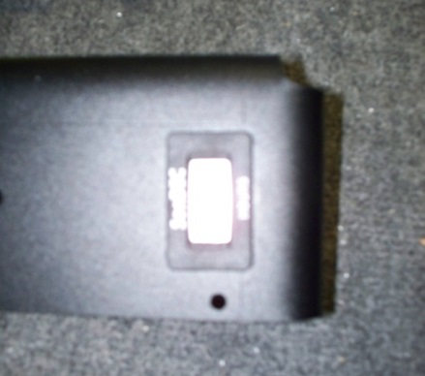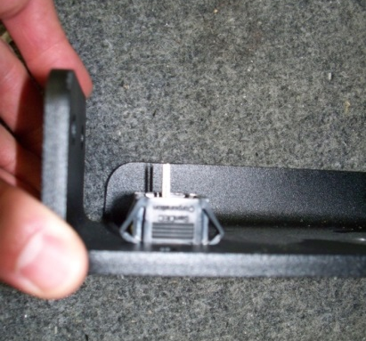

  - Take a battery clamp support (89822) and stick a propane tank pad (89823) to the top of it as shown.

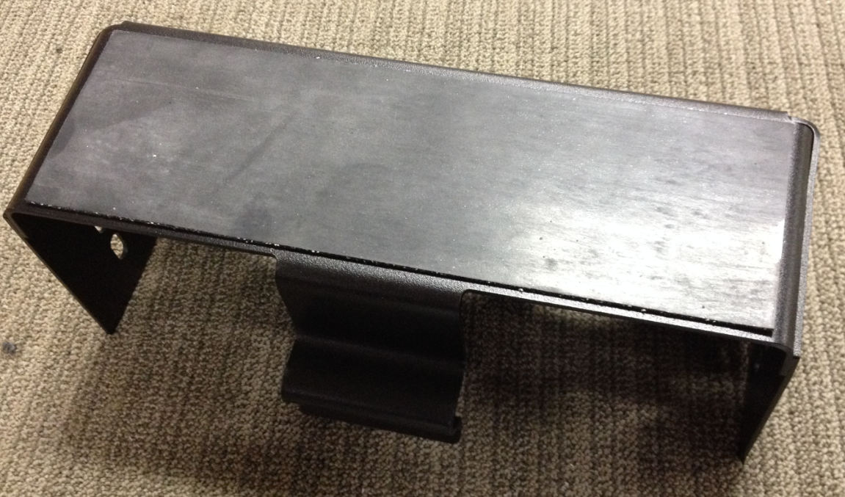

  - Take a front tank strap (88807) and stick a 2.5” piece of felt (10457) onto the center of it as shown.

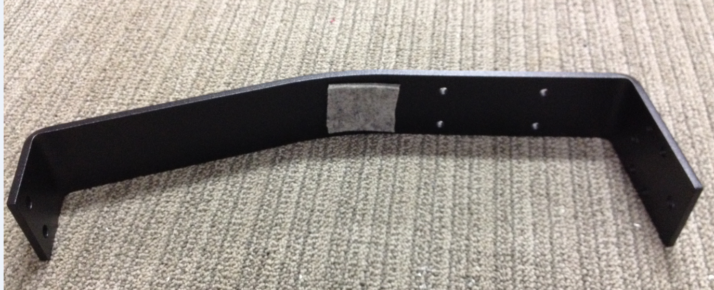
  - Take the back tank strap (86120) and stick a 22” piece of felt (10457) onto the inside of it as shown.

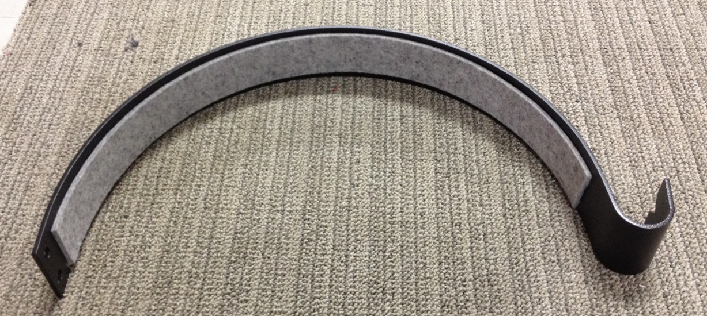

  - Take a handle bar weldment (88808) and use a rubber mallet to pound a hand grip (12696) onto each end of the handle. Put some glue onto the inside of the grip before installing. This will make sure that it does not slide off.

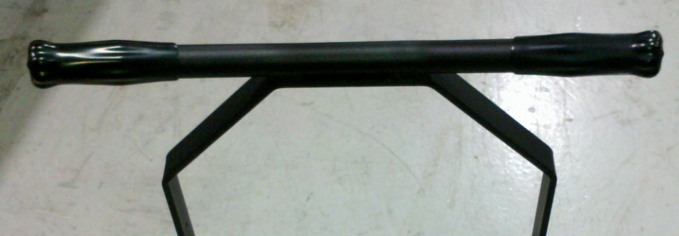

  - Open up the plastic bag that holds the components of the clamp (11702). Locate the arm of the clamp and thread the jam nut onto it. Insert the arm into the pivot block in the clamp. Ensure that the flat area of the pivot block rests against the jam nut. Install the nylon lock nut onto the end of the arm with a ½” socket. Tighten it so that the shaft of the arm just starts to stick out the back. All remaining components from the plastic bag can be discarded.

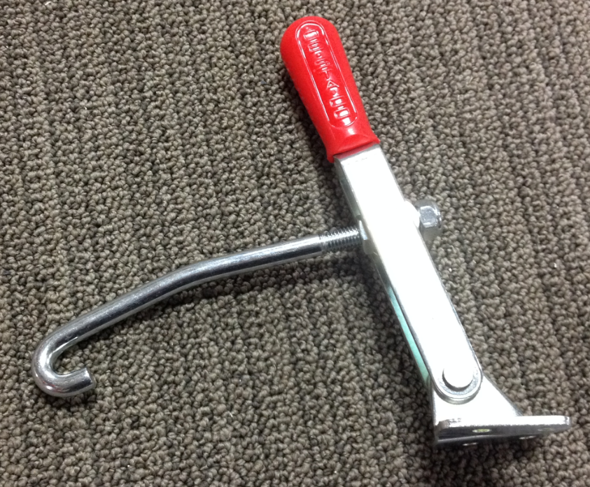
Lock Nut
Jam Nut
Arm

- References (optional section as needed)

- Training Guide

Functional Training Groups Requiring Training
Equipment Assembly Group

- SOP Change Control

Date of Change | Reason for Change
Rev 01 - 11/22/2013 | This is the first version of the S.O.P. hence there are no revisions to this document.
Rev 02 - 1/12/2018 | Added the Responsibilities Section
Rev 03 - 5/4/2018 | Updated for the Optima XR upgrades
Rev 04 - 3/21/2025 | Removed work center notes and updated machine ID list

Approvals

Submitter/Author Approval:__________________________________ Date:______________________

Management Approval:______________________________________ Date:______________________

QAU Approval:_____________________________________________ Date:______________________

